Title: Simulate a Full Adder in VHDL.
Problem Description: Develop a program in Verilog to perform full adder operation.
Full adder

module Fulladder12(sum,cout,a,b,c);
input a,b,c;
output sum,cout;
assign sum=a^b^c;
assign cout=(a&b)|(b&c)|(c&a);
endmodule;

Title: Simulate a 8:1 MUX in VHDL
Problem Description: Develop a program in VHDL to perform 8:1 multiplexer operation.

module m81(out, D0, D1, D2, D3, D4, D5, D6, D7, S0, S1, S2);
input wire D0, D1, D2, D3, D4, D5, D6, D7, S0, S1, S2;
output reg out;
always@(*)
begin
case({S0,S1,S2})
3'b000: out=D0;
3'b001: out=D1;
3'b010: out=D2;
3'b011: out=D3;
3'b100: out=D4;
3'b101: out=D5;
3'b110: out=D6;
3'b111: out=D7;
default: out=1'b0;
endcase
end
endmodule

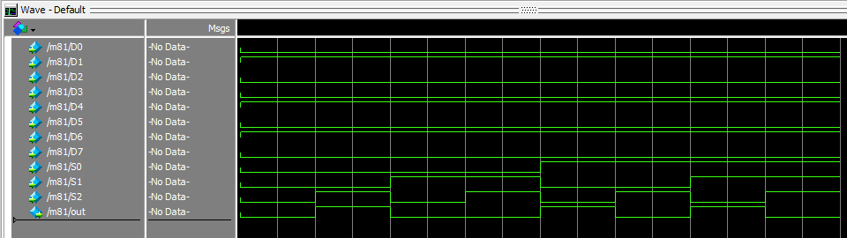

Title: Simulate a Flip-Flops in Verilog.
Problem Description: Develop a program in verilog to check the working of flip-flops (JK/D/T)
module jk_ff ( input j, input k, input clk, output reg q);
initial begin
q=0;
end
always @ (posedge clk)
begin
case ({j,k})
2'b00 : q <= q;
2'b01 : q <= 0;
2'b10 : q <= 1;
2'b11 : q <= ~q;
endcase
end
endmodule

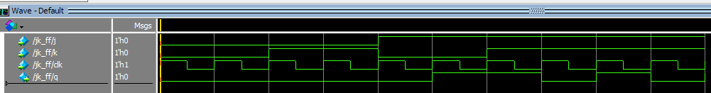

Counter
Title: Simulate a 4-bit binary counter VHDL program.
Problem Description: Develop a program in VHDL to check 4-bit binary counter.

module counter (input clk, // Declare input port for the clock to allow counter to count up
input rstn, // Declare input port for the reset to allow the counter to be reset to 0 when required
output reg[3:0] out); // Declare 4-bit output port to get the counter values

// This always block will be triggered at the rising edge of clk (0->1)
// Once inside this block, it checks if the reset is 0, then change out to zero
// If reset is 1, then the design should be allowed to count up, so increment the counter

always @ (posedge clk) begin
if (! rstn)
out <= 0;
else
out <= out + 1;
end
endmodule

Ripple carry adder
Title: Simulate a 4-bit binary counter VHDL program.
Problem Description: Develop a program in VHDL to check 4-bit binary counter.

module rippe_adder(X, Y, S, Co);
input [3:0] X, Y;// Two 4-bit inputs
output [3:0] S;
output Co;
wire w1, w2, w3;
// instantiating 4 1-bit full adders in Verilog
fulladder u1(X[0], Y[0], 1'b0, S[0], w1);
fulladder u2(X[1], Y[1], w1, S[1], w2);
fulladder u3(X[2], Y[2], w2, S[2], w3);
fulladder u4(X[3], Y[3], w3, S[3], Co);
endmodule

module Fulladder12(a,b,c,sum,cout,);
input a,b,c;
output sum,cout;
assign sum=a^b^c;
assign cout=(a&b)|(b&c)|(c&a);
endmodule;

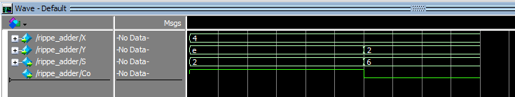

4 bit ALU
Title: Design of a 4-bit ALU.
Problem Description: Develop a program in VHDL to perform 4-bit ALU.

module alu(
input [7:0] A,B, // ALU 8-bit Inputs
input [3:0] ALU_Sel,// ALU Selection
output [7:0] ALU_Out, // ALU 8-bit Output
output CarryOut // Carry Out Flag
);
reg [7:0] ALU_Result;
wire [8:0] tmp;
assign ALU_Out = ALU_Result; // ALU out
assign tmp = {1'b0,A} + {1'b0,B};
assign CarryOut = tmp[8]; // Carryout flag
always @(*)
begin
case(ALU_Sel)
4'b0000: // Addition
ALU_Result = A + B ;
4'b0001: // Subtraction
ALU_Result = A - B ;
4'b0010: // Multiplication
ALU_Result = A * B;
4'b0011: // Division
ALU_Result = A/B;
4'b0100: // Logical shift left
ALU_Result = A<<1;
4'b0101: // Logical shift right
ALU_Result = A>>1;
4'b0110: // Rotate left
ALU_Result = {A[6:0],A[7]};
4'b0111: // Rotate right
ALU_Result = {A[0],A[7:1]};
4'b1000: // Logical and
ALU_Result = A & B;
4'b1001: // Logical or
ALU_Result = A | B;
4'b1010: // Logical xor
ALU_Result = A ^ B;
4'b1011: // Logical nor
ALU_Result = ~(A | B);
4'b1100: // Logical nand
ALU_Result = ~(A & B);
4'b1101: // Logical xnor
ALU_Result = ~(A ^ B);
4'b1110: // Greater comparison
ALU_Result = (A>B)?8'd1:8'd0 ;
4'b1111: // Equal comparison
ALU_Result = (A==B)?8'd1:8'd0 ;
default: ALU_Result = A + B ;
endcase
end

endmodule
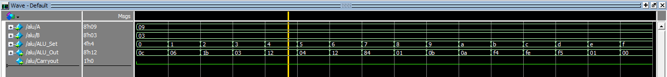

Alu_SET | Operation | ALU_Result
4'b0000: // Addition | A+B
4'b0001: // Subtraction | A-B
4'b0010: // Multiplication | A * B
4'b0011: // Division | A/B;
4'b0100: // Logical shift left | A<<1;
4'b0101: // Logical shift right | A>>1
4'b0110: // Rotate left | {A[6:0],A[7]}
4'b0111: // Rotate right | {A[0],A[7:1]};
4'b1000: // Logical and | A & B
4'b1001: // Logical or | A | B
4'b1010: // Logical xor | A^B
4'b1011: // Logical nor | ~(A | B)
4'b1100: // Logical nand | ~(A & B)
4'b1101: // Logical xnor | ~(A ^ B)
4'b1110: // Greater comparison | (A>B)
4'b1111: // Equal comparison | (A==B)

